Hong Kong Exchanges and Clearing Limited and The Stock Exchange of Hong Kong Limited take no responsibility for the contents of this announcement, make no representation as to its accuracy or completeness and expressly disclaim any liability whatsoever for any loss howsoever arising from or in reliance upon the whole or any part of the contents of this announcement.

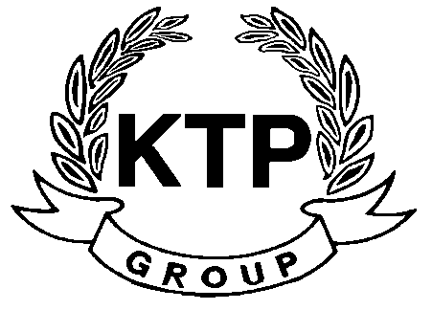
KTP HOLDINGS LIMITED
港台集團有限公司*
(Incorporated in Bermuda with limited liability)
(Stock Code: 645)

POLL RESULTS OF THE ANNUAL GENERAL MEETING HELD ON
20TH AUGUST 2010

The Board is pleased to announce that all the ordinary resolutions proposed at the AGM held on 20th August 2010 were duly passed.

Reference is made to the Company’s notice of annual general meeting (the “AGM Notice”) and circular (the “Circular”) dated 23rd July 2010. Unless otherwise stated, terms used in this announcement shall have the same meanings as those defined in the Circular.

The Board is pleased to announce that all the ordinary resolutions set out in the AGM notice were duly passed by way of poll voting at the AGM held on 20th August 2010. The Company’s Branch Share Registrar in Hong Kong, Computershare Hong Kong Investor Services Limited, acted as the scrutineer for the vote-taking at the AGM.

The poll results are as follows:

Ordinary resolutions proposed at the AGM |  | Number of votes cast (%)
 |  | For | Against
1. | To receive and consider the audited consolidated financial statements of the Company and the reports of the directors and auditors for the year ended 31 March 2010. | 222,891,982  (100%) | 0  (0%)
2. (i) | To re-elect Mr. Ng Wai Hung as an independent non-executive director. | 204,481,582  (91.74%) | 18,410,400  (8.26%)
(ii) | To re-elect Mr. Lee Siu Leung as an independent non-executive director. | 204,481,582  (91.74%) | 18,410,400  (8.26%)
(iii) | To authorise the board of directors to fix directors’ remuneration. | 205,041,982  (91.99%) | 17,850,000  (8.01%)

Ordinary resolutions proposed at the AGM |  | Number of votes cast (%)
 |  | For | Against
3. | To re-appoint Messrs. SHINEWING (HK) CPA Limited as auditors of the Company and to authorise the board of directors to fix auditors’ remuneration. | 222,891,982  (100%) | 0  (0%)
4. | To give a general mandate to the directors to purchase the Company’s shares not exceeding 10% of the aggregate nominal amount of the issued share capital of the Company as at the date of passing of this resolution. | 222,891,982  (100%) | 0  (0%)
5. | To give a general mandate to the directors to issue, allot and deal with additional shares of the Company not exceeding 20% of the aggregate nominal amount of the issued share capital of the Company as at the date of passing of this resolution. | 203,881,582  (91.47%) | 19,010,400  (8.53%)
6. | To extend the general mandate granted to the directors to issue, allot and deal with additional shares in the capital of the Company by the aggregate nominal amount of shares repurchased by the Company. | 203,881,582  (91.47%) | 19,010,400  (8.53%)

As at the date of AGM, the total number of Shares in issue was 340,616,934, which was the total number of Shares entitling the holders to attend and vote for or against the resolutions proposed at the AGM. None of the Shares entitled the holders to attend and vote only against the resolutions proposed at the AGM. No shareholders were required to abstain from voting on any of the resolutions at the AGM.

By the Order of the Board
KTP HOLDINGS LIMITED
Lee Chi Keung Russell
Chairman

Hong Kong, 20th August 2010

*For identification purpose only

As at the date of this announcement, the Board is comprised of 5 Directors, of which Mr. LEE Chi Keung, Russell(Chairman) and Miss. YU Mee See, Maria are executive Directors, Mr. NG Wai Hung, LEE Siu Leung and Mr. YUEN Sik Ming are independent non-executive Directors.

